**BMI CALCULATOR**

**SNIPPET**

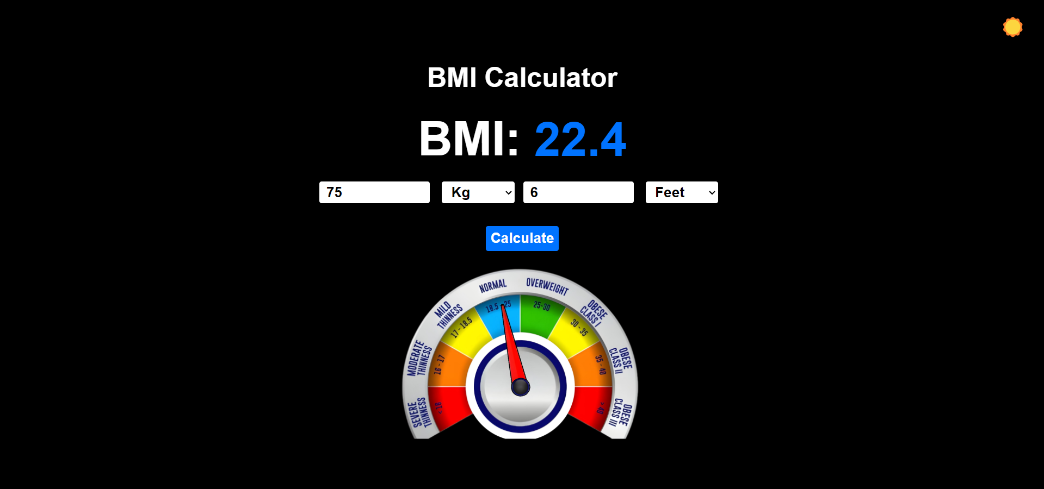

**SOURCE CODE**

**HTML:**

<!DOCTYPE html>

<html lang="en">

<head>

    <meta charset="UTF-8">

    <meta name="viewport" content="width=device-width, initial-scale=1.0">

    <title>BMI Calculator</title>

    <link rel="stylesheet" href="style.css">

</head>

<body>

    <button id="dark-mode-toggle">☀️</button>

    <div class="main-body">

        <h1 style="font-size: 40px;">BMI Calculator</h1>

        <div style="display: flex; justify-content: center; align-items: center; flex-direction: row;">

            <p style="font-size: 70px; font-weight: bold; margin: 0;">BMI:&nbsp</p>

            <p class="bmi" style="font-size: 70px; font-weight: bold; margin: 0; color: rgb(0, 115, 255);">0</p>

        </div>

            <div class="input">

                <div class="height-input">

                    <input class="weight" type="text" placeholder="Weight">

                    <select class="weight-unit">

                        <option value="Kg">Kg</option>

                        <option value="Pound">Pound</option>

                        <option value="Ton">Ton</option>

                    </select>

                </div>

                <div class="weight-input">

                    <input class="height" type="text" placeholder="Height">

                    <select class="height-unit">

                        <option value="Feet">Feet</option>

                        <option value="Meters">Meters</option>

                        <option value="Inches">Inches</option>

                        <option value="Cm">Cm</option>

                        <option value="Km">Km</option>

                    </select>

                </div>

            </div>

            <input class="calculate-btn" type="submit" value="Calculate" onclick="calculate()">

        <div class="meter">

            <img src="images/Scale.png" width="400px" class="scale">

            <img src="images/Gauge.png" width="150px" class="gauge">

        </div>

    </div>

    <script src="script.js"></script>

</body>

</html>

**CSS:**

body{

    display: flex;

    justify-content: center;

    align-items: center;

    height: 97vh;

    font-family: Arial;

}

.main-body {

    display: flex;

    justify-content: center;

    align-items: center;

    flex-direction: column;

}

.form {

    display: flex;

    justify-content: center;

    align-items: center;

    flex-direction: column;

}

.input {

    display: flex;

    justify-content: center;

    align-items: center;

    flex-direction: row;

    margin-top: 20px;

    margin-bottom: 20px;

}

.weight, .height {

    width: 150px;

    height: 30px;

    font-size: 21px;

    font-weight: bold;

    padding-left: 10px;

    margin-right: 10px;

    border: 2px solid black;

    border-radius: 5px;

}

.height-unit, .weight-unit {

    width: 110px;

    height: 35px;

    font-size: 21px;

    font-weight: bold;

    padding-left: 10px;

    margin-right: 10px;

    border: 2px solid black;

    border-radius: 5px;

}

.calculate-btn {

    width: 110px;

    height: 40px;

    font-size: 21px;

    font-weight: bold;

    margin-top: 10px;

    border: 2px solid black;

    border-radius: 5px;

    background-color: rgb(0, 115, 255);

    color: rgb(0, 0, 0);

    cursor: pointer;

}

.meter {

    position: relative;

    display: inline-block;

}

.gauge {

    position: absolute;

    top: 70%;

    left: 36%;

    transform: translate(-50%, -50%);

    transform: translate(-50%, -50%) rotate(-35deg);

    transform-origin: 86% 49%;

    transition: transform 0.7s cubic-bezier(0.25, 1.5, 0.5, 1);

}

@keyframes vibrate {

    0% { transform: translate(-50%, -50%) rotate(197deg); }

    25% { transform: translate(-50%, -50%) rotate(199deg); }

    50% { transform: translate(-50%, -50%) rotate(197deg); }

    75% { transform: translate(-50%, -50%) rotate(195deg); }

    100% { transform: translate(-50%, -50%) rotate(197deg); }

}

.vibrate {

    animation: vibrate 0.1s linear infinite;

}

#dark-mode-toggle {

    position: absolute;

    top: 20px;

    right: 20px;

    background-color: transparent;

    border: none;

    font-size: 30px;

}

**JavaScript:**

var bmi = 0;

function calculate(){

    var height = document.querySelector(".height").value;

    var weight = document.querySelector(".weight").value;

    if(/^-?\d+(\.\d+)?$/.test(height) === false || /^-?\d+(\.\d+)?$/.test(weight) === false){

        return;

    }

    var heightUnit = document.querySelector(".height-unit").value;

    var weightUnit = document.querySelector(".weight-unit").value;

    if(heightUnit === "Cm"){

        height = eval(height/100);

    }

    else if(heightUnit === "Inches"){

        height = eval(height*0.0254);

    }

    else if(heightUnit === "Feet"){

        height = eval(height*0.3048);

    }

    else if(heightUnit === "Km"){

        height = eval(height*1000);

    }

    if(weightUnit === "Pound"){

        weight = eval(weight*0.453592);

    }

    else if(weightUnit === "Ton"){

        weight = eval(weight*1000);

    }

    bmi = eval(weight/(height**2)).toFixed(1);

    if(bmi <= 50 && bmi >= 10){

        document.querySelector(".bmi").style.height = "79px";

        animateBmi(bmi);

    }

    else{

        document.querySelector(".bmi").style.height = "106px";

        document.querySelector(".bmi").innerHTML = `${bmi} 💀`;

    }

    rotateGauge(getRotationDegree(bmi));

}

function getRotationDegree(value) {

    if (value < 16) {

        return (value / 16) * 33;

    } else if (value >= 16 && value <= 17) {

        return 33 + (value - 16) * (63 - 33);

    } else if (value > 17 && value <= 18.5) {

        return 63 + (value - 17) * (93 - 63) / 1.5;

    } else if (value > 18.5 && value <= 25) {

        return 93 + (value - 18.5) * (124 - 93) / (25 - 18.5);

    } else if (value > 25 && value <= 30) {

        return 124 + (value - 25) * (154 - 124) / (30 - 25);

    } else if (value > 30 && value <= 35) {

        return 154 + (value - 30) * (185 - 154) / (35 - 30);

    } else if (value > 35 && value <= 40) {

        return 185 + (value - 35) * (215 - 185) / (40 - 35);

    } else {

        return 230;

    }

}

function rotateGauge(angle) {

    const gauge = document.querySelector(".gauge");

    gauge.style.transform = `translate(-50%, -50%) rotate(${angle-35}deg)`;

    console.log(angle);

    if (bmi > 40) {

        gauge.style.transform = `translate(-50%, -50%) rotate(193deg)`;

        setTimeout(() => {

            gauge.classList.add('vibrate');

        }, 600);

    } else {

        gauge.classList.remove('vibrate');

    }

}

function animateBmi(bmi) {

    let i = 0;

    const interval = 10;

    const step = 1;

    const bmiElement = document.querySelector(".bmi");

    const timer = setInterval(() => {

        if (i >= bmi) {

            clearInterval(timer);

            i = bmi;

        }

        bmiElement.innerHTML = i;

        i += step;

    }, interval);

}

const darkModeToggle = document.getElementById('dark-mode-toggle');

var buttons = document.querySelectorAll('#reset, #autoinc, #autodec, #stop');

if (localStorage.getItem('darkMode') === 'enabled') {

    enableDarkMode();

} else {

    disableDarkMode();

}

darkModeToggle.addEventListener('click', () => {

    if (localStorage.getItem('darkMode') !== 'enabled') {

        enableDarkMode();

    } else {

        disableDarkMode();

    }

});

function enableDarkMode() {

    darkModeToggle.innerHTML = '☀️';

    document.body.style.backgroundColor = 'black';

    document.querySelector('.calculate-btn').style.color = 'white';

    document.body.style.color = 'white';

    localStorage.setItem('darkMode', 'enabled');

}

function disableDarkMode() {

    darkModeToggle.innerHTML = '🌑';

    document.body.style.backgroundColor = 'white';

    document.querySelector('.calculate-btn').style.color = 'black';

    document.body.style.color = 'black';

    localStorage.setItem('darkMode', 'disabled');

}

document.addEventListener('keydown', function(event) {

    if (event.key === 'Enter') {

        calculate();

    }

});

**GitHub:** [**https://github.com/DMegatron/BMI-Calculator**](https://github.com/DMegatron/BMI-Calculator)